Chapter 4: Chemical elements

4.1 The properties of matter can be described

Literacy support worksheet answers (pages 62–63)

Properties of matter

1 What is matter?

Matter is the name given to all substances.

2 To be called matter, a substance must have two things. List them below and explain what they are measured in.

a Mass: measured in kilograms and defined as the amount of matter a substance has

b Volume: measured in Litres and defined as how much space a substance takes up

Part 1 – Solids, liquids and gases

3 Are the substances in the following pictures solids, liquids or gases or a mixture?

|  |  |  |  |  |
| --- | --- | --- | --- | --- |
| a Gas cloud | b Liquid lava (yellow/red), solid rock (black) | c Solid ice cream | d Liquid milk, solid glass | e Solid bunsen burner, gas in flame |
| f Solid toast | g Liquid water | h Gas steam, solid cup | i Solid snowflake | j Solid carbon diamond |

Part 2 – Chemical and physical properties

4 What are some examples of what might happen during a chemical reaction?

a Bubbling

b Permanent colour change

c Permanent change of state

5 What is a physical property of matter?

A physical property of matter is what we can observe and measure without changing the substance into something else.

6 What are the physical properties of the following substances?

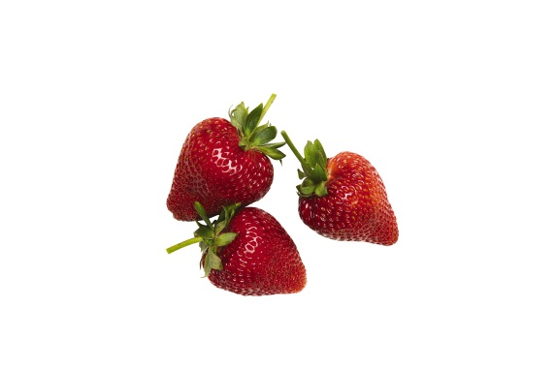

Colour = red and green

Texture = smooth skin, leaves have more texture



Colour = white and black

Shape/volume = sphere

Texture = smooth with ridges around pentagons

Word detective

7 Quick quiz

Circle whether the following situations show P – Physical properties, or C – Chemical properties.

a Water boils at 100ᵒC

P

b Diamond is used to cut glass.

P

c Salt is able to dissolve in water.

P

d Paper is flammable.

C

e Magnesium metal will burn to form a white powder.

C

f Nitrogen is a gas at room temperature.

P

g A ball of aluminium will sink faster in water than a piece of aluminium foil.

P

h If your car is left in the rain, the Iron will form rust.

C

i A sheet of aluminium is battered with a hammer until flat.

P

j Vapour pours out of the freezer as you get out the ice cream.

P

k The cling wrap melts over the plate of food in the microwave.

C

l A cake burns in the oven.

C

4.2 Science as a human endeavour: Scientists’ understanding of matter has developed over thousands of years

Literacy support worksheet answers (pages 64–65)

An introduction to particle theory

Part 1 – Scientists’ contribution to particle theory

1 Scientific theory involves at least three steps. What are they?

a Developing hypotheses

b Testing them with reproducible experiments

c Modifying ideas

2 What does the word ‘atomos’ mean?

Indivisible

3 Name two things that modem chemistry was able to discover about particle theory that Dalton and Democritus were not.

Answers will vary but may include:Particles are always moving, there are spaces between particles and forces hold particles together to stop them from separating. (Other ideas relate too strongly to Dalton’s.)

Particles have mass.

Part 2 – How do particles behave in solids, liquids and gases?

4 States of matter differ in several ways. Using the diagram and information on page 65 *Oxford Science 8*, answer the questions below.

Am I a solid, liquid or gas? My particles:

a are very closely packed together: solid

b move over one another without moving away from each other: liquid

c will fill an entire container: gas

5 Using Figure 4.6 in Oxford Science 8, finish the sentences below.

Each molecule contains: two hydrogen atoms and one oxygen atom.

A molecule is made up of: two different types of atoms.

6 Look around the room and find three things that are solids, two things that are liquids and at least one gas.

Three solids:

Answers may vary to include: chair, table, floor, walls, hair, skin, books

Two liquids:

Answers may vary to include: water, saliva, blood, pen/ink

A gas:

Air, Bunsen burner gas

Word discovery

7 Draw and label

Draw and label the particles found in a solid, a liquid and a gas. Use the diagrams on the bottom of page 65 of *Oxford Science 8* to help you.Use the following phrases in your labels:

Particles bound closely together

Particles moving around each other more freely

Particles moving quickly and separate from each other

Answers will vary

4.3 The particle model explains matter

Literacy support worksheet answers (pages 66–67)

Using the particle model to explain matter

Part 1 – Kinetic theory of matter

1 The pictures below have been compared to states of matter. Name the state of matter (solid, liquid or gas) and explain how the things in the images compare to that state in their structure and they way that they move. Use the information on p 66 of Oxford Science 8 to help you. The first one has been done for you.

|  |  |
| --- | --- |
| a Eggs in a carton | State of matter: Solid  Structure: There is a fixed structure.  Movement: There is no movement of the eggs and there is no kinetic energy. |
| b. Balls in a ball pit | State of matter: Liquid  Structure: The balls in the pit are able to move about and have no fixed structure.  Movement: Although some balls may fly into the air they are not moving by themselves. They have some kinetic energy. |
| c. A school of fish swimming in all directions | State of matter: Gas  Structure: There is no fixed structure, fish are moving freely.  Movement: The fish have a great deal of energy and are moving very fast in all directions. They have a high amount of kinetic energy |
| d. A wall built out of Lego blocks | State of matter: Solid  Structure: There is a set structure.  Movement: This is similar to the movement of solids where there is only vibration. They have a low amount of kinetic energy |
| e Dandelion fluff forming aircrafts in the sky | State of matter: Gas  Structure: There is a fixed structure.  Movement: The fluff has a great deal of energy and they are moving very fast in all directions. They have a high amount of kinetic energy |

Part 2 – Diffusion

Answers will vary and may include the following suggestions.

2 Give an example of diffusion.

The smell of perfume wafting through the room

3 Give an example of diffusion in a liquid.

Tea spreading out from a tea bag in hot water

4 Why does diffusion occur the fastest in gases?

Because the particles in gases are moving freely and quickly

5 If you spray air freshener on one side of the room, you can typically smell it in a very short space of time. Explain why this is.

This is because of diffusion of the movement of particles from an area of high concentration to an area of low concentration.

6 Refer to the pictures in Q5. If a liquid diffuser was used instead of a spray, would it take you more or less time to smell the fragrance?

It would take more time.

7 The following diagram represents a tea bag in a hot cup of water. In the glasses provided, demonstrate what happens to the tea as it diffuses through the water.

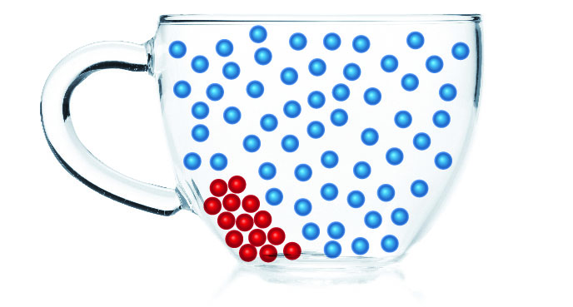→ 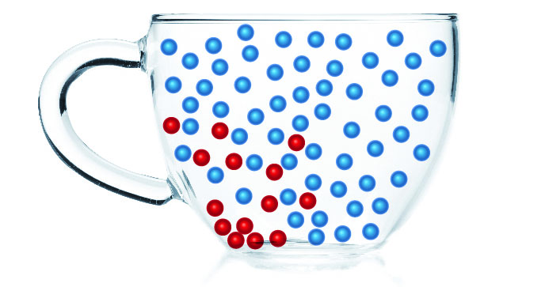→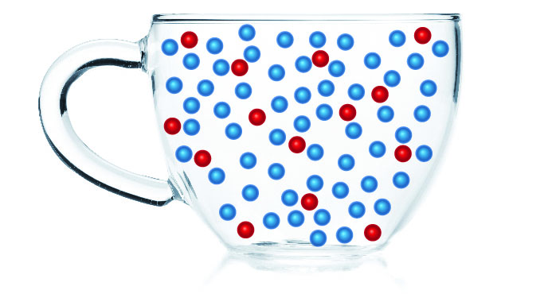

Word detective

8 Secret message

Use words from the Student Book to complete the puzzle. Then, use your answers to complete the sentence below.

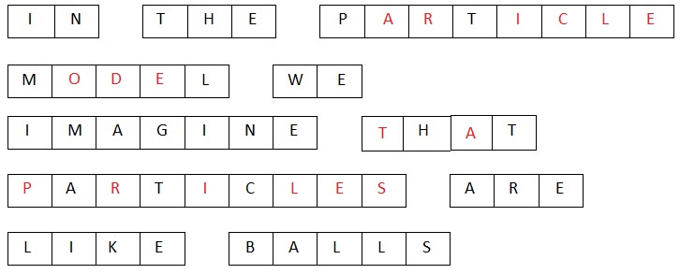

4.4 The particle model can explain the properties of matter

Literacy support worksheet answers (pages 68–69)

Using the particle model to explain properties of matter

Part 1 – Strength

1 What is tensile strength?

Tensile strength is a measure of the flexibility of the links or bonds between particles.

2 Circle whether wire or a rubber band has greater tensile strength. Explain why.

The rubber band has a higher tensile strength. This is because it is more flexible and easily stretched.

3 Compressional strength is the ability to withstand large forces without being crushed. Circle whether a piece of rock candy or a marshmallow would have greater compressional strength. Explain why.

The marshmallow has a greater compressional strength as you can apply forces without it crushing. Applying the same forces to the rock candy will make it shatter.

Part 2 – Hardness

4 Explain what hardness.

The ability of a substance to scratch another substance.

5 Circle the substance which would be more brittle. Explain why.

The graphite is more brittle. This is because, although it is hard, is will shatter when dropped (e.g. dropping a pencil) unlike a diamond.

Part 3 – Viscosity

6 Which substance would have a greater viscosity? Explain why.

The honey will have a greater viscosity than the water. This is because it is harder to pour, and it is very gooey and thick.

Part 4 – Compressibility

7 Using your knowledge of the particle model of matter, explain why it is possible to compress a gas. (Refer to Figure 4.16 on page 69 of *Oxford Science 8* to help you).

Gases have space between their particles which can be reduced when compacted into a smaller space.

8 Why is it that solids or liquids cannot be compressed? (Refer to Figure 4.8 on page 66 of *Oxford Science 8* to help you).

There is no space between the particles in a solid or gas, therefore there is no way to reduce the space between particles.

Part 5 – Density

9 Cork is made of wood and it is less dense than water. Use the table to:

a The density of wood is 0.3 g/cm3 and the density of water is 1.0g/cm3.

b The material listed with the highest density is gold.

10 Why does the cork float in water?

The density of wood is 0.3 g/cm3 and air is 0.001g/cm3, compared to water at 1.0g/cm3. This means that wood already has a lower density and will float on water.

Word detective

11 Mumbo jumbo

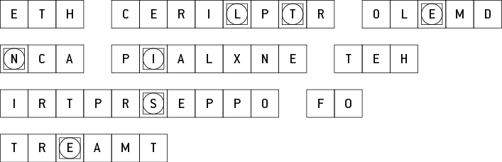

Message: The particle model can explain the properties of matter.

Secret word: tensile.

4.5 Increasing kinetic energy in matter causes it to expand

Literacy support worksheet answers (pages 70–71)

Heating particles and expansion

Part 1 – Heating particles

1 In the circles, draw what the particles look like as liquids or gases (solid has been done for you).

On the black lines, write whether there is an increase or decrease in energy and an increase or decrease in heat (the first one has been done for you).

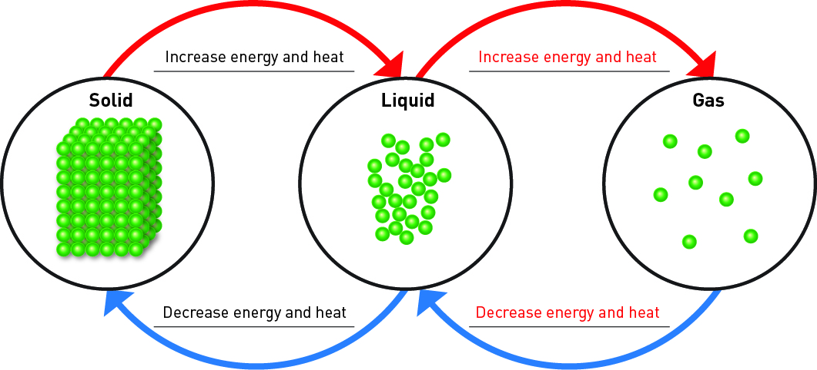

2 When a solid changes to a liquid:

a What happens to the movement of particles?

Particles that are tightly packed spread apart and flow over one another.

b Why does particle movement change?

As you increase energy, the movement of particles increases.

3 When a liquid changes to a gas, why does particle movement change?

As you increase energy, the movement of particles increases.

4 For each change in state, give an example from your daily life.

a Solid to liquid:

Ice turning into liquid water

b Liquid to gas:

Kettle boiling water to produce steam

c Solid to gas:

Solid carbon dioxide (dry ice) turn into CO2 gas

d Gas to liquid:

Water vapour in the air turns into condensation on the grass on cool mornings

e Liquid to solid:

When placed in a freezer, liquid water forms solid ice cubes

f Gas to solid:

Water vapour in the air forms snow and frost on very cold days

Part 2 – Heat causes expansion

5 Finish the end of this sentence: When you put a thermometer in your mouth, it causes the liquid to:

Expand. Particles will speed up, take up more space and push the other particles further apart (expand) causing it to rise to a higher temperature measurement.

6 When you cannot open the lid of a jar of spaghetti sauce, you may run the lid under a hot tap to open it. Why might this work?

Running the metallic lid under the hot tap would cause the particles to heat up/gain more energy, move more and expand. When it expands it will break the seal of the jar causing it to be opened more easily.

7 Sometimes on a hot day, you may not be able to get a ring on your finger that normally fits. Why not?

When your body has a higher temperature, the particles in the finger will speed up, take up more space and push the other particles further apart (expand) causing the fluid in the the finger to expand. This means that the finger is slightly bigger in size and the ring may be harder to get on and off.

Word detective

8 Crossword

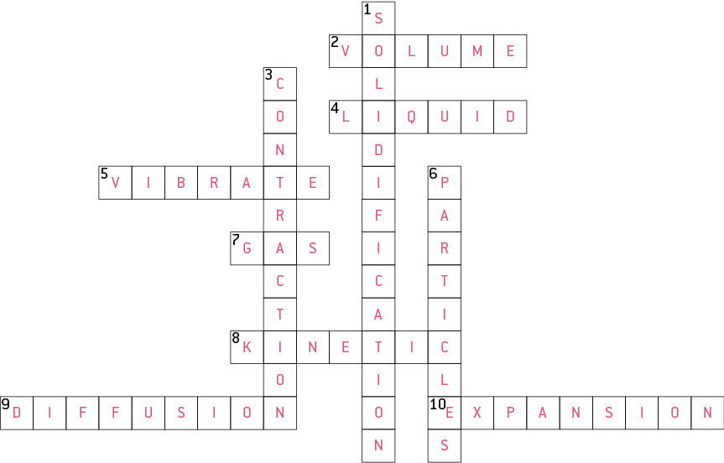

4.6 Atoms and elements make up matter

Literacy support worksheet answers (pages 72–73)

Atoms, elements and the periodic table

1 Match the following statement to its correct element by drawing a line between them.

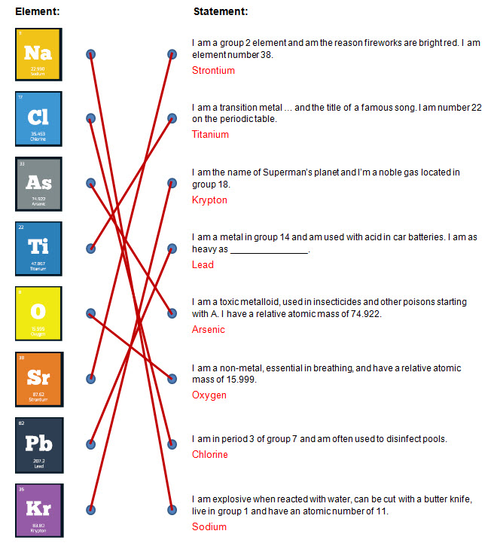

2 Use the clues below to fill in the crossword.

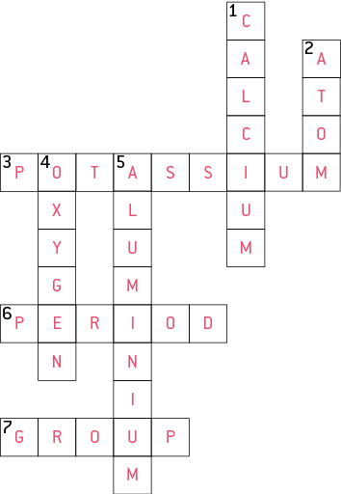

Word detective

3 True or false

Read the statement and circle whether it is true or false.

a ‘Atmos’ means particles that cannot be broken down any further

T

b The smallest atom in terms of mass is Helium

F

c Boron (B) and aluminium (Al) are likely to have similar properties

T

d Nitrogen is a diatomic gas

T

e An element is an impure substance made up of only one atom

F

f Artificially made atoms are too small to be stable

F

4.7 Atoms bond together to make molecules and compounds

Literacy support worksheet answers (pages 74–75)

Molecules, compounds and mixtures

Part 1 – Molecules

1 What is the difference between a molecular element and a molecular compound? Complete the end of the sentences:

A molecular element contains two or more atoms of the same element where as a molecular compound contains two or more atoms of different elements.

2 Name and draw two examples of molecular elements below. An example has been provided for you. (Other molecular elements might include N2 and O2).

|  |  |  |
| --- | --- | --- |
|  |  |  |

3 Write and draw two examples of molecular compounds below. An example has been provided for you. (See p 74 of *Oxford Science 8* for other molecular compounds).

|  |  |  |
| --- | --- | --- |
| Hydrogen peroxide: | Water: | Carbon Monoxide: |

Part 2 – Compounds and mixtures

4 What is a compound?

A compound is two or more atoms of different elements bonded together.

5 What is a mixture?

A mixture contains two more compounds but they are not bonded together.

6 Name and draw two examples of compounds below (an example has been provided for you).

|  |  |  |
| --- | --- | --- |
| Water: | Hydrogen peroxide: | Carbon monoxide: |

7 Draw two examples of mixtures below (an example has been provided for you):

|  |  |  |
| --- | --- | --- |
|  |  |  |

8 Some compounds are molecules like CO2 and some are polymers. What are polymers?

Polymers are groups of atoms that repeat over and over, like beads on a necklace.

9 Complete the chart of the different types of substances from your student book and draw examples of the bottom three substances in the boxes provided.

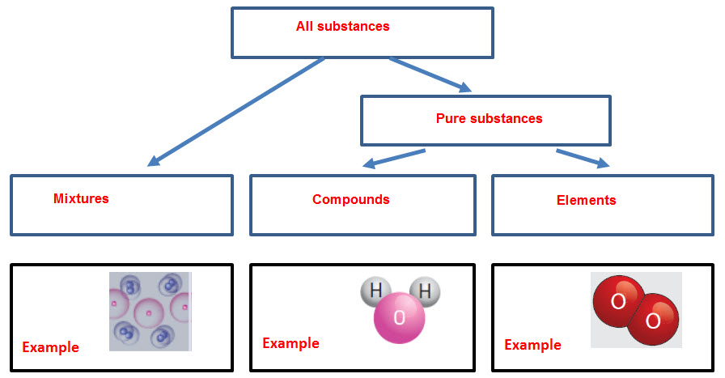

Word detective

10 Matching meaning. Draw a line from the picture to its description

